WEEK 3 INTERNSHIP REPORT
Statistical Analysis and Hypothesis Testing in Python

Internship: Data Science with Python Internship

Dataset: Student Performance Dataset – Mathematics Course
INTRODUCTION:
Student academic performance can be influenced by several factors, including study habits and the amount of time students spend studying. In this analysis, the relationship between study time and final academic performance is examined using the Student Performance dataset. The students are divided into two groups based on their study time: Higher Study Time and Lower Study Time. Their final grades (G3) are then compared to determine whether students who spend more time studying tend to achieve better results.
Statistical analysis is used to check whether the difference between the two groups is meaningful rather than simply due to random variation. The analysis includes descriptive statistics, visualizations, Levene's test, an independent samples t-test, a confidence interval, and Cohen's d effect size. The findings provide statistical evidence about the relationship between study time and academic performance and help determine whether the proposed hypothesis is supported.

OBJECTIVE:

The main objective of this analysis is to determine whether students with higher study time achieve higher final grades than students with lower study time. Statistical tests and visualizations are used to compare the two groups and evaluate whether the observed difference is statistically significant.

DATASET DESCRIPTION:
The Student Performance dataset was used for this analysis. It contains information about students studying Mathematics and Portuguese, along with details about their demographic background, family characteristics, study habits, previous academic performance, and absences. The Mathematics dataset contains 395 records, while the Portuguese dataset contains 649 records. Both datasets were combined into a single dataset, resulting in 1,044 student records. The main variables used in this statistical analysis were study time and G3. The study time variable represents the amount of weekly study time, with values ranging from 1 to 4. The G3 variable represents the student's final grade, with values ranging from 0 to 20. For hypothesis testing, study time was divided into two groups. Students with study time values of 1 or 2 were classified as Lower Study Time, while students with values of 3 or 4 were classified as Higher Study Time. The Lower Study Time group contained 820 records, while the Higher Study Time group contained 224 records.
Code snippet used for dataset preparation:
mat_df = pd.read_csv(
"student_data/extracted/student-mat.csv",
sep=";"
)
por_df = pd.read_csv(
"student_data/extracted/student-por.csv",
sep=";"
)
mat_df["subject"] = "Mathematics"
por_df["subject"] = "Portuguese"
df = pd.concat(
[mat_df, por_df],
ignore_index=True
)
print("Mathematics records:", len(mat_df))
print("Portuguese records:", len(por_df))
print("Combined records:", len(df))

HYPOTHESIS:

The purpose of the hypothesis test is to determine whether there is a statistically significant difference in final grades between students with lower and higher study time.
Research Question:
Do students with higher study time have significantly different final grades compared with students with lower study time?
Null Hypothesis (H₀):
There is no statistically significant difference in the mean final grades between students with lower and higher study time.
Alternative Hypothesis (H₁):
There is a statistically significant difference in the mean final grades between students with lower and higher study time.
Significance Level (α): 0.05

Decision Rule: If the p-value is less than 0.05, the null hypothesis will be rejected. If the p-value is greater than or equal to 0.05, the null hypothesis will not be rejected.

Statistical Test:An independent samples t-test was selected because the analysis compares the mean final grades of two independent study-time groups. Levene's test was first used to check the equality of variances between the groups.

METHODOLOGY:
The analysis was performed using Python with Pandas, NumPy, Matplotlib, and SciPy. The Mathematics and Portuguese datasets were loaded and combined into a single dataset containing 1,044 records. The studytime variable was used to divide students into two groups. Students with study-time values of 1 or 2 were classified as Lower Study Time, while students with values of 3 or 4 were classified as Higher Study Time. The final grade (G3) was used as the measure of academic performance.
First, descriptive statistics including sample size, mean, median, and standard deviation were calculated for both groups. Visualizations were then created to compare the distributions and average grades. Before conducting the t-test, Levene's test was performed to check whether the two groups had significantly different variances. Since the result did not indicate a significant difference in variances, an independent samples t-test assuming equal variances was used.
The t-test was used to determine whether the difference in mean final grades between the two groups was statistically significant at a significance level of 0.05. A 95% confidence interval for the difference in means was also calculated. Finally, Cohen's d was calculated to measure the practical size of the difference between the two groups.
Code snippet used for group creation:
df["study_group"] = np.where(
df["studytime"].isin([1, 2]),
"Lower Study Time",
"Higher Study Time"
)
print(df["study_group"].value_counts())
group_statistics = df.groupby("study_group")["G3"].agg(
["count", "mean", "median", "std"]
)
print(group_statistics)

DESCRIPTIVE STATISTICS AND INITIAL FINDINGS:
Descriptive statistics were calculated before conducting the hypothesis test to understand the basic differences between the two study-time groups. The Lower Study Time group contained 820 students, while the Higher Study Time group contained 224 students.
The Lower Study Time group had an average final grade of 11.04, with a median of 11.00 and a standard deviation of 3.83. The Higher Study Time group had an average final grade of 12.43, with a median of 13.00 and a standard deviation of 3.79.
The Higher Study Time group therefore had an average final grade approximately 1.39 points higher than the Lower Study Time group. The standard deviations of the two groups were also similar, indicating comparable variation in final grades.
Study-Time Group | Number of Students | Mean G3 | Median G3 | Standard Deviation
Lower Study Time | 820 | 11.04 | 11.00 | 3.83
Higher Study Time | 224 | 12.43 | 13.00 | 3.79
These descriptive results suggest a difference in academic performance between the two groups. However, descriptive statistics alone cannot determine whether the observed difference is statistically significant. Therefore, formal hypothesis testing was performed using Levene's test and an independent samples t-test.
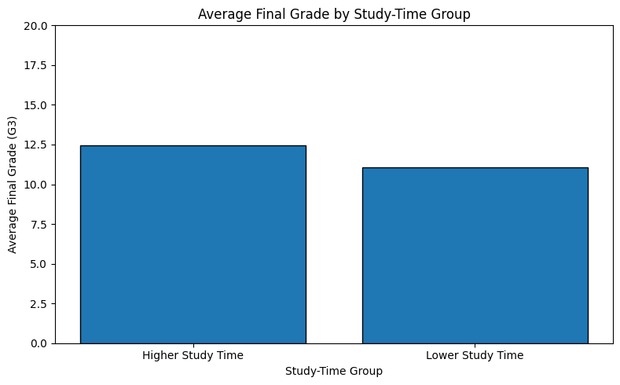
The chart shows that students in the Higher Study Time group had a higher average final grade than students in the Lower Study Time group. This provides an initial visual comparison before statistical testing.

VISUAL ANALYSIS:
Visualizations were used to understand the difference in academic performance between the Lower Study Time and Higher Study Time groups. The first visualization compares the average final grades of the two groups and shows that the Higher Study Time group achieved a higher average grade of 12.43 compared with 11.04 for the Lower Study Time group. The box plot provides additional information about the distribution of grades, including the median, spread, and potential outliers in both groups. The third visualization presents the mean final grades with 95% confidence intervals, giving a clearer view of the uncertainty around the estimated group means. Finally, the mean-difference visualization shows an average difference of approximately 1.39 grade points between the two groups. Overall, the visualizations provide an initial indication that students in the Higher Study Time group tend to have better final grades. However, visual differences alone cannot determine whether the observed difference is statistically significant. Therefore, statistical tests were performed to formally evaluate the hypothesis.

- Average Final Grade by Study-Time Group

The bar chart compares the average final grade of students in the two study-time groups. The Higher Study Time group has an average final grade of 12.43, while the Lower Study Time group has an average of 11.04. The chart provides an initial visual indication that the two groups differ in academic performance.

Distribution of Final Grades
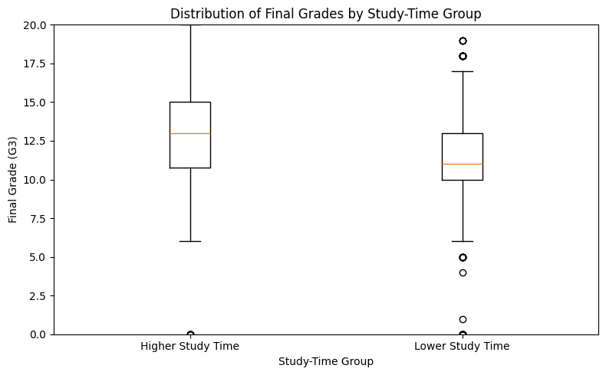
The box plot shows the distribution of final grades for both study-time groups. The median final grade is higher for the Higher Study Time group. The plot also shows variation within each group and several individual observations outside the main distribution. These points are potential outliers and were retained because they represent actual observations in the dataset.

Mean Final Grade with 95% Confidence Intervals
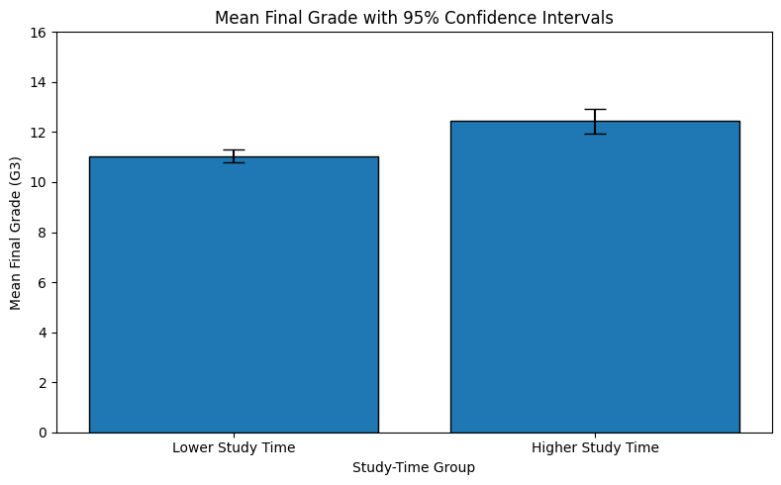
This visualization compares the mean final grades of the two groups while displaying 95% confidence intervals around the group means. The Higher Study Time group has the higher estimated mean. The confidence intervals provide information about the uncertainty around each group's mean and support the comparison made during the statistical analysis.
- Difference in Mean Final Grades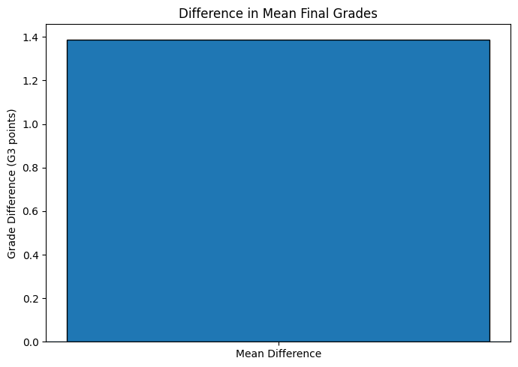

The chart shows that the Higher Study Time group has an average final grade approximately 1.39 points higher than the Lower Study Time group. This difference is later evaluated using the independent samples t-test to determine whether it is statistically significant.

LEVENE'S TEST:
Levene's test was performed to determine whether the variances of final grades were significantly different between the Lower Study Time and Higher Study Time groups. This test was used before the independent samples t-test to determine whether the equal-variance assumption was reasonable. Levene's test produced a test statistic of 0.0042 and a p-value of 0.9486. Since the p-value is greater than the significance level of 0.05, the null hypothesis of equal variances is not rejected. Therefore, there is no statistically significant evidence that the two groups have different variances. Based on this result, the independent samples t-test was performed assuming equal variances.
Code snippet used for levene’s test:
levene_stat, levene_p = stats.levene(
higher_study,
lower_study
)
print("Levene's Test")
print("Statistic:", levene_stat)
print("p-value:", levene_p)

INDEPENDENT SAMPLES T-TEST:
An independent samples t-test was performed to determine whether the difference in mean final grades between the Lower Study Time and Higher Study Time groups was statistically significant. The test produced a t-statistic of 4.8181 and a p-value of 1.664 × 10⁻⁶. The significance level was set at 0.05.
Statistic | Value
t-statistic | 4.8181
p-value | 0.000001664
Significance level | 0.05
Decision | Reject H₀
Since the p-value is much smaller than 0.05, the null hypothesis is rejected. This provides strong statistical evidence that the mean final grades of the two study-time groups are significantly different. The descriptive statistics show that the Higher Study Time group had a mean final grade of 12.43, compared with 11.04 for the Lower Study Time group. Therefore, the difference is in favor of the Higher Study Time group. However, the result should be interpreted as an association rather than proof of causation. Other factors in the dataset may also contribute to differences in academic performance.
Code snippet used for independent sample t-test:
t_stat, p_value = stats.ttest_ind(
higher_study,
lower_study,
equal_var=True
)
print("Independent Samples t-test")
print("t-statistic:", t_stat)
print("p-value:", p_value)

CONFIDENCE INTERVAL:
A 95% confidence interval was calculated to estimate the range of the difference in mean final grades between the Higher Study Time and Lower Study Time groups.The observed difference in mean grades was 1.39 points. The 95% confidence interval ranged from 0.82 to 1.95 grade points. This means that, based on the sample data, the difference in population mean final grades is estimated to fall between approximately 0.82 and 1.95 points with 95% confidence. Since the confidence interval does not include zero, it provides additional evidence that the two groups have different mean final grades.
Measure | Value
Mean difference | 1.389
95% CI Lower | 0.823
95% CI Upper | 1.955

Code snippet used to find the mean difference and etc:
mean_difference = higher_study.mean() - lower_study.mean()
n1 = len(higher_study)
n2 = len(lower_study)
pooled_variance = (
((n1 - 1) * higher_study.var(ddof=1)) +
((n2 - 1) * lower_study.var(ddof=1))
) / (n1 + n2 - 2)
standard_error = np.sqrt(
pooled_variance * (1/n1 + 1/n2)
)
df_ttest = n1 + n2 - 2
critical_t = stats.t.ppf(
0.975,
df_ttest
)
margin_error = critical_t * standard_error
ci_lower = mean_difference - margin_error
ci_upper = mean_difference + margin_error
print("Mean difference:", mean_difference)
print("95% Confidence Interval:")
print("Lower:", ci_lower)
print("Upper:", ci_upper)

EFFECT SIZE — COHEN'S D:
Cohen's d was calculated to measure the size of the difference in final grades between the Higher Study Time and Lower Study Time groups. While the p-value indicates whether the observed difference is statistically significant, Cohen's d provides additional information about the magnitude of the difference.
The calculated Cohen's d was 0.363. This represents a small-to-moderate effect size, indicating that the difference between the two study-time groups is noticeable but not extremely large. Therefore, although the statistical test found a significant difference in average final grades, the effect size suggests that study time alone is unlikely to explain all differences in student performance. Other factors may also contribute to academic outcomes.

Measure | Value
Cohen's d | 0.3632
Interpretation | Small-to-moderate effect

Code snippet used to find cohen’s d:
n1 = len(higher_study)
n2 = len(lower_study)
pooled_std = np.sqrt(
(
(n1 - 1) * higher_study.var(ddof=1)
+ (n2 - 1) * lower_study.var(ddof=1)
)
/ (n1 + n2 - 2)
)
cohens_d = (
higher_study.mean() - lower_study.mean()
) / pooled_std
print("Cohen's d:", cohens_d)

RESULTS AND INTERPRETATION:
The statistical analysis found a clear difference in final grades between the two study-time groups. Students in the Higher Study Time group had a mean final grade of 12.43, while students in the Lower Study Time group had a mean of 11.04. The difference between the two means was approximately 1.39 grade points.
Levene's test produced a p-value of 0.9486, which was greater than 0.05. Therefore, there was no significant evidence of unequal variances, and the equal-variance version of the independent samples t-test was used.
The independent samples t-test produced a t-statistic of 4.8181 and a p-value of 1.664 × 10⁻⁶. Since the p-value is less than 0.05, the null hypothesis was rejected. This indicates that there is a statistically significant difference in mean final grades between the two study-time groups.The 95% confidence interval for the difference in means was 0.82 to 1.95 grade points. Since zero is not included in this interval, the confidence interval also supports the conclusion that the groups differ. Cohen's d was 0.363, indicating a small-to-moderate effect. Therefore, the results suggest that higher study time is associated with higher final grades, although study time alone does not explain all differences in academic performance.
Measure | Result
Lower Study Time mean | 11.04
Higher Study Time mean | 12.43
Mean difference | 1.39
Levene's p-value | 0.9486
t-statistic | 4.8181
t-test p-value | 0.000001664
95% CI | 0.82 – 1.95
Cohen's d | 0.363

EDUCATIONAL AND SCIENTIFIC IMPLICATIONS:
The results of this analysis may be useful for understanding factors related to student academic performance. The Higher Study Time group had a higher average final grade than the Lower Study Time group, and the statistical test showed that this difference was significant. From an educational perspective, the findings suggest that study habits may be an important factor to consider when supporting students. Schools and educators could encourage effective study routines and provide appropriate academic support to students who may need additional help.
However, the results should not be interpreted as proof that increasing study time alone will automatically improve grades. Academic performance can also be influenced by previous grades, attendance, family background, motivation, and other factors. Further analysis using multiple variables could provide a more complete understanding of student performance. From a scientific perspective, the analysis demonstrates how hypothesis testing can be used to evaluate whether an observed difference in a dataset is statistically meaningful rather than relying only on visual comparisons or averages.
FINAL CONCLUSION :
This analysis investigated whether students with higher study time have significantly different final grades compared with students with lower study time. The results showed that the Higher Study Time group had a mean final grade of 12.43, compared with 11.04 for the Lower Study Time group. The independent samples t-test produced a p-value of 1.664 × 10⁻⁶, which is below the 0.05 significance level. Therefore, the null hypothesis was rejected. The 95% confidence interval for the mean difference was 0.82 to 1.95, while Cohen's d was 0.363.
Overall, the findings provide statistical evidence of an association between study-time group and final academic grade in this dataset. The effect was small-to-moderate, so other factors should also be considered when studying student performance.

